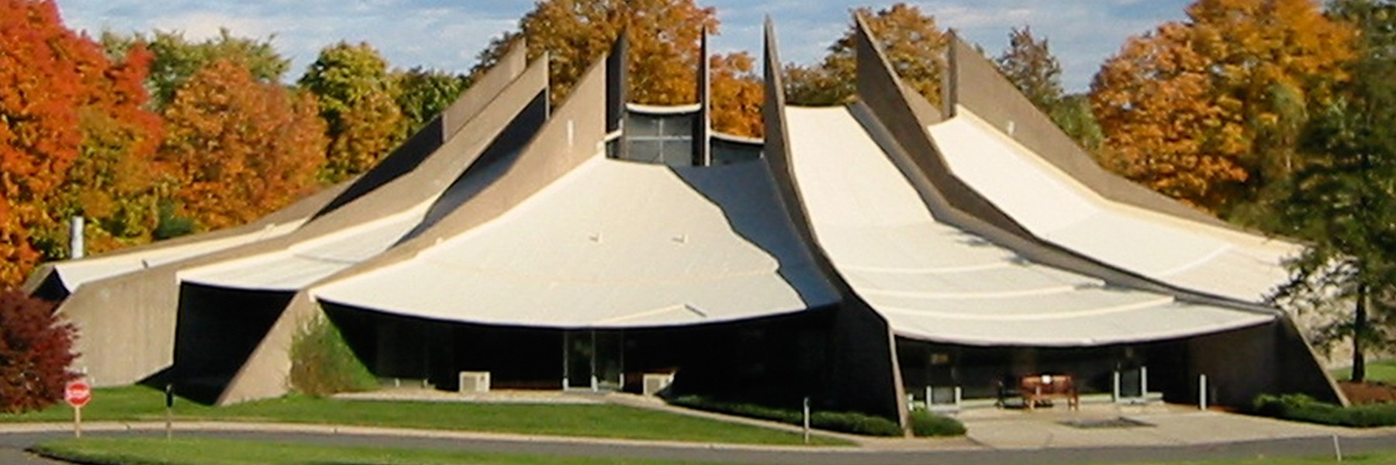

RE Registration Form 2024-2025
For safety and administrative reasons, the Religious Education Committee asks that you complete this registration form. Only one form is needed per family. This printable form is also available on the USH website at hartforduu.org.
Today’s Date: ______________
Section 1 - Parent/Guardian Information:

Parent/Guardian #1 - Last Name: _____________First Name: __________________

Address (street name with apartment number if applicable):

_______________________________City: _____________Zip code: ________________

Primary Phone Number (please indicate if it is a home, mobile, or work number): ______________

Secondary Phone Number (please indicate if it is a home, mobile, or work number): ____________

Email Address (please include an email you frequently check for updates on our RE events!):

________________________________________________

Parent/Guardian #2 - Last Name: _____________First Name: __________________

Address (street name with apartment number if applicable):

_______________________________City: _____________Zip code: ________________

Primary Phone Number (please indicate if it is a home, mobile, or work number): ______________

Secondary Phone Number (please indicate if it is a home, mobile, or work number): ____________

Email Address (please include an email you frequently check for updates on our RE events!):

________________________________________________


Children live with:
Parent Guardian #1.
Parent Guardian #2. Both.
Other:

Section 2 - Student Information:

Child #1 - Last name:
First Name (feel free to include nicknames and/or preferred names!): My child's preferred pronouns are:
He/Him. She/Her.
They/Them.
Other:
Birthdate: Age today:
Grade level as of August, 2024: _______________
Name of school district of private school (if homeschooled, please indicate.) This helps us plan our RE calendar.
____________________________________________________________________________

Child #2 - Last name:
First Name (feel free to include nicknames and/or preferred names!): My child's preferred pronouns are:
He/Him. She/Her.
They/Them.
Other:
Birthdate: Age today:
Grade level as of August, 2024: _______________
Name of school district of private school (if homeschooled, please indicate.) This helps us plan our RE calendar.

Would you be willing to make a one-time contribution of $50 to help with RE Program costs?

_____Yes

______No
Please reach out to our Religious Education Director about allergies, need for mobility assistance, developmental issues, gender identity, or any other personal concerns. This helps us to better meet the needs of your child. If you would prefer to share this information in person, please indicate and our associate of religious education will be in touch.
Section 3 - Additional Information:

PHOTO PERMISSION: Please check the YES box if you give the Religious Education Program permission to use your child(ren)'s photographs in various publications created by and for USH. Please note: We will not include the names of children with photos.
 YES, you have my permission to use my child(ren)’s photographs.
NO, you do not have my permission to use my child(ren)’s photographs.
RE Volunteers wanted! Please consider volunteering in our RE classroom or for a one-time event:
Yes, I would be willing to volunteer. Please contact me.
No, not at this time.
Thank you for taking the time to fill out this form!
Upon completion, please email to: shahan@hartforduu.org or put in Shahan’s box @ USH or slip under RE office door.

